LINE CHART - EMPLOYEE PERFORMANCE TREND
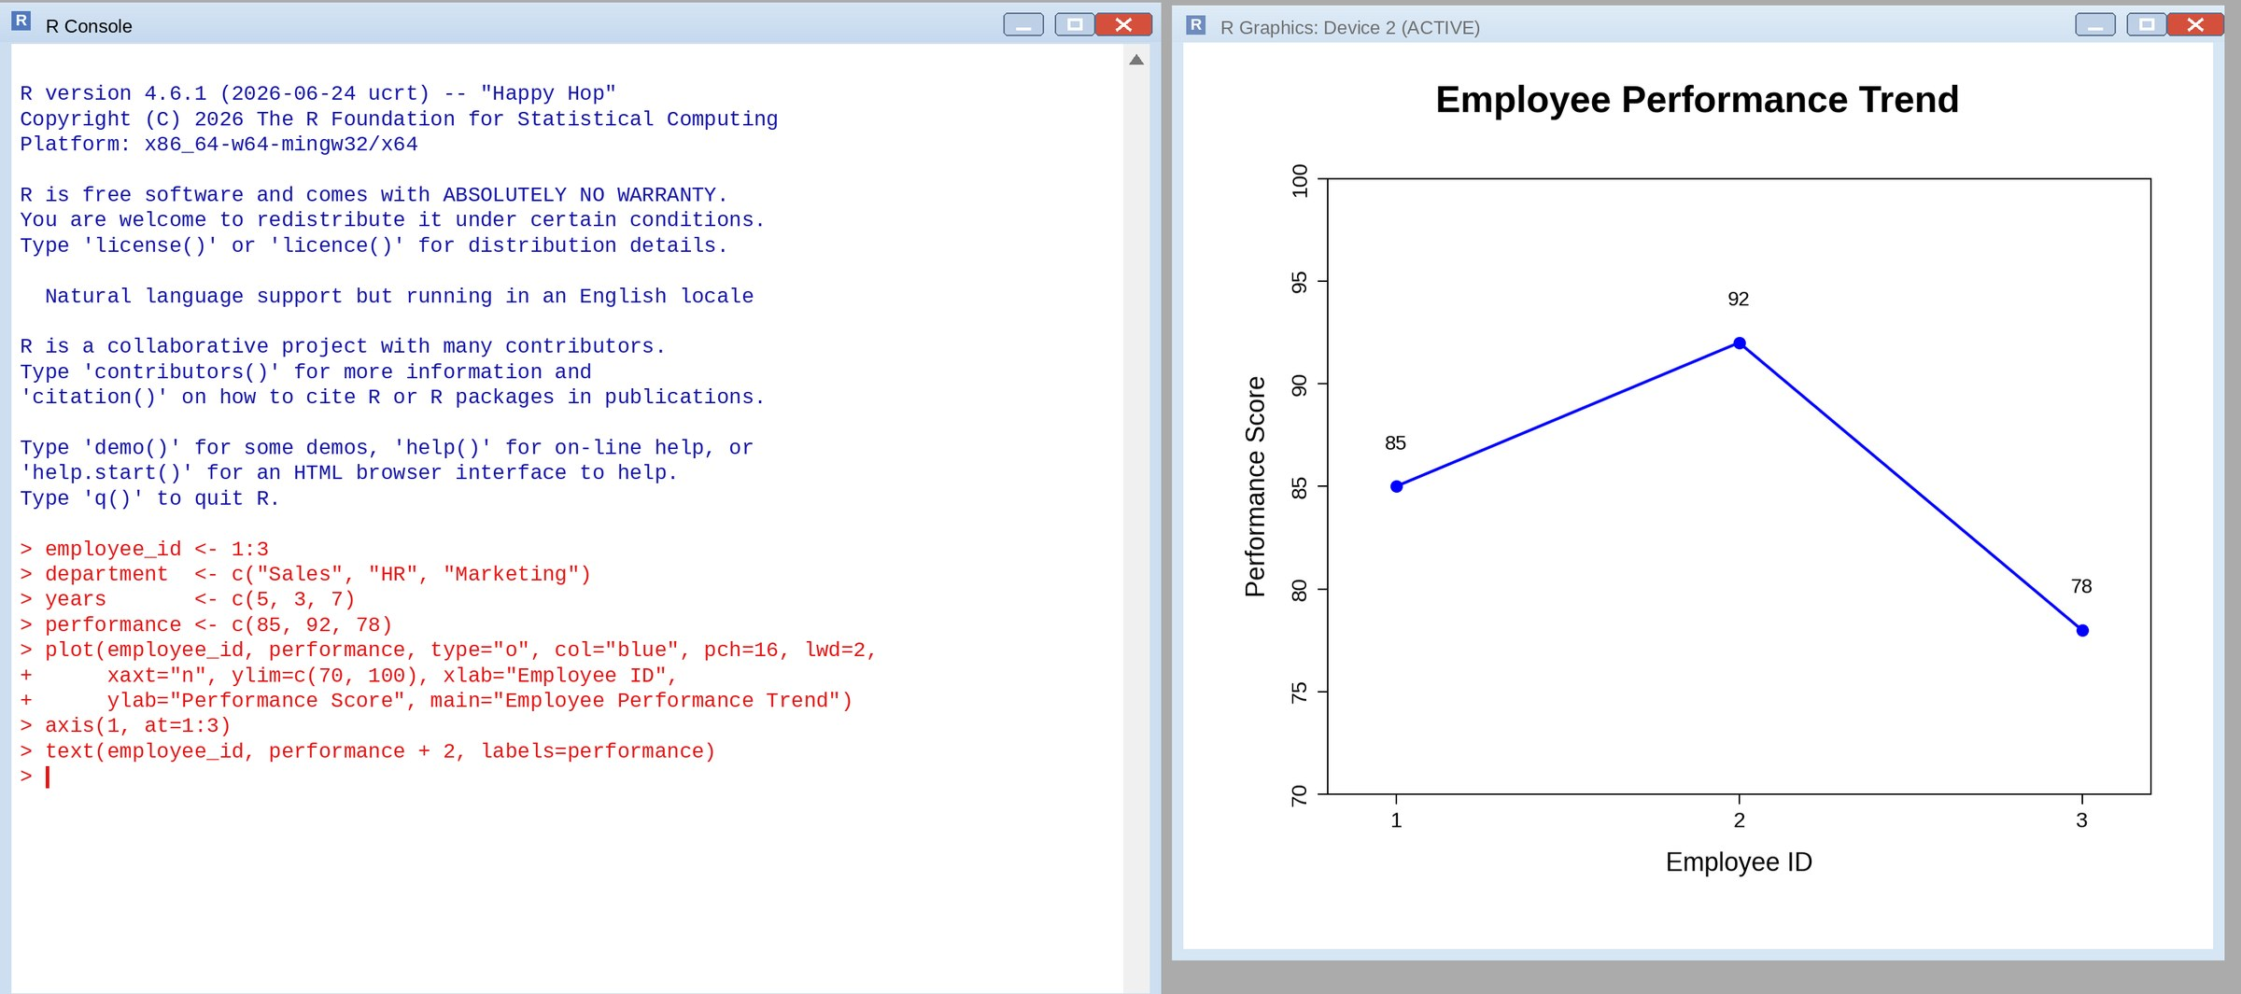
BAR CHART - EMPLOYEES BY DEPARTMENT
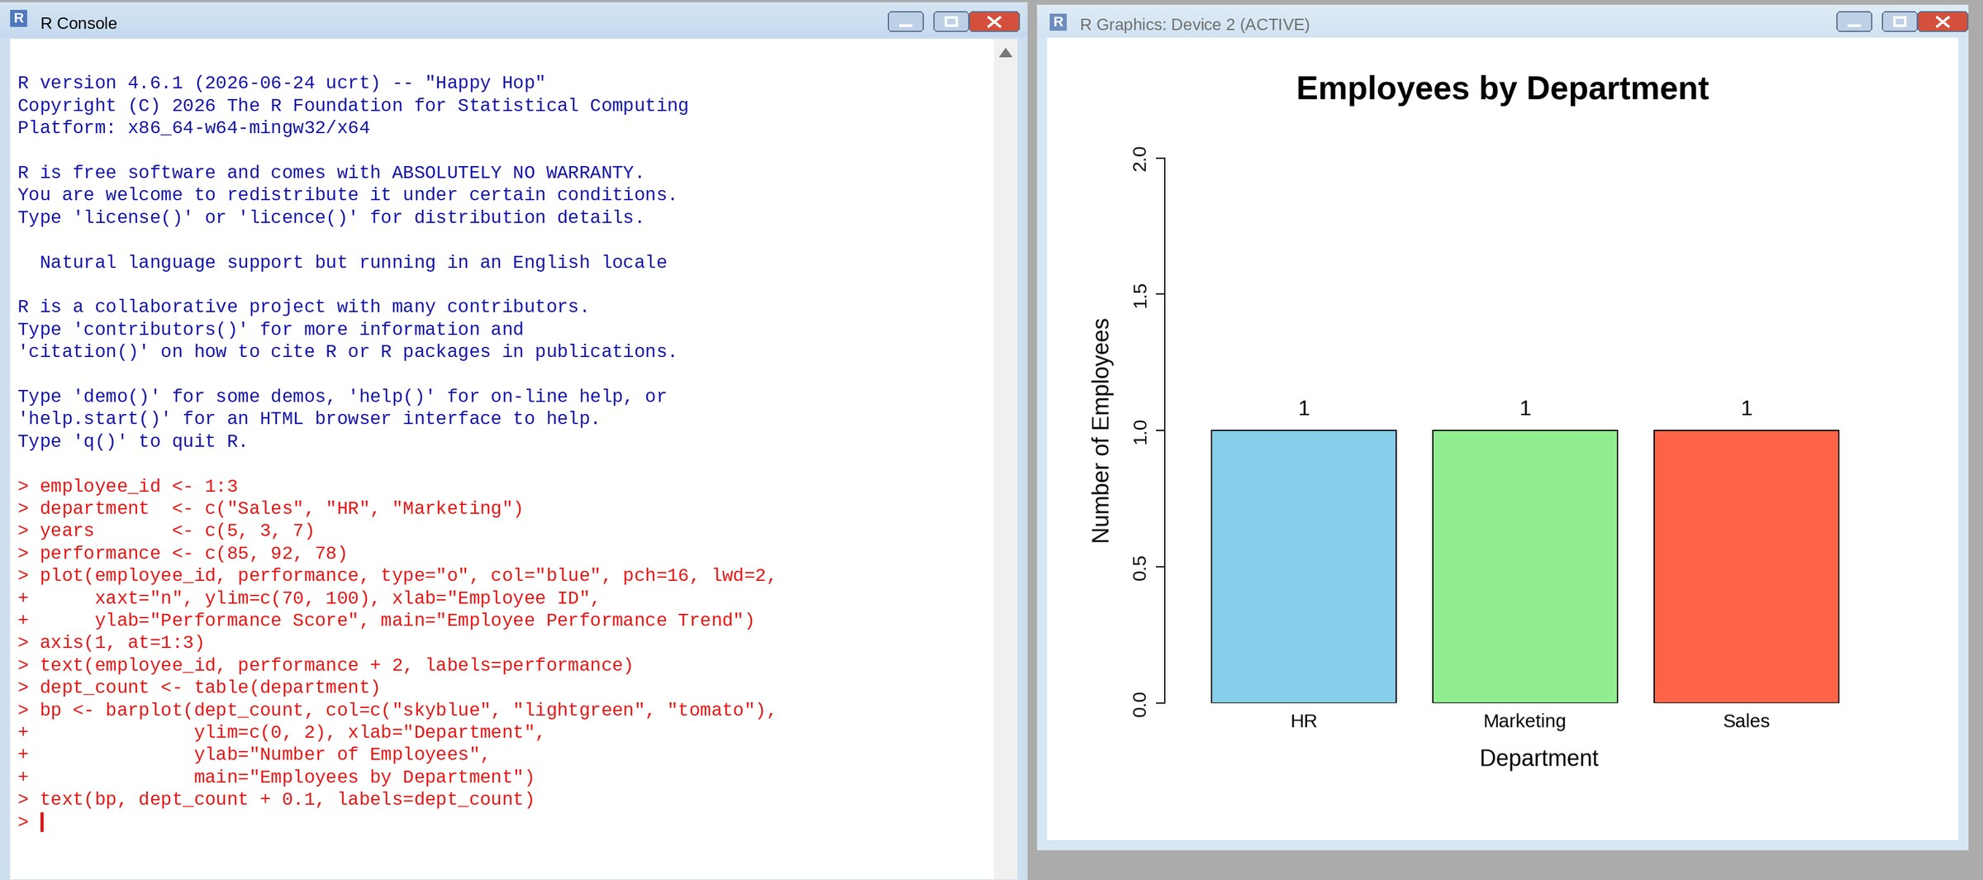
TABLE - EMPLOYEE PERFORMANCE DATA
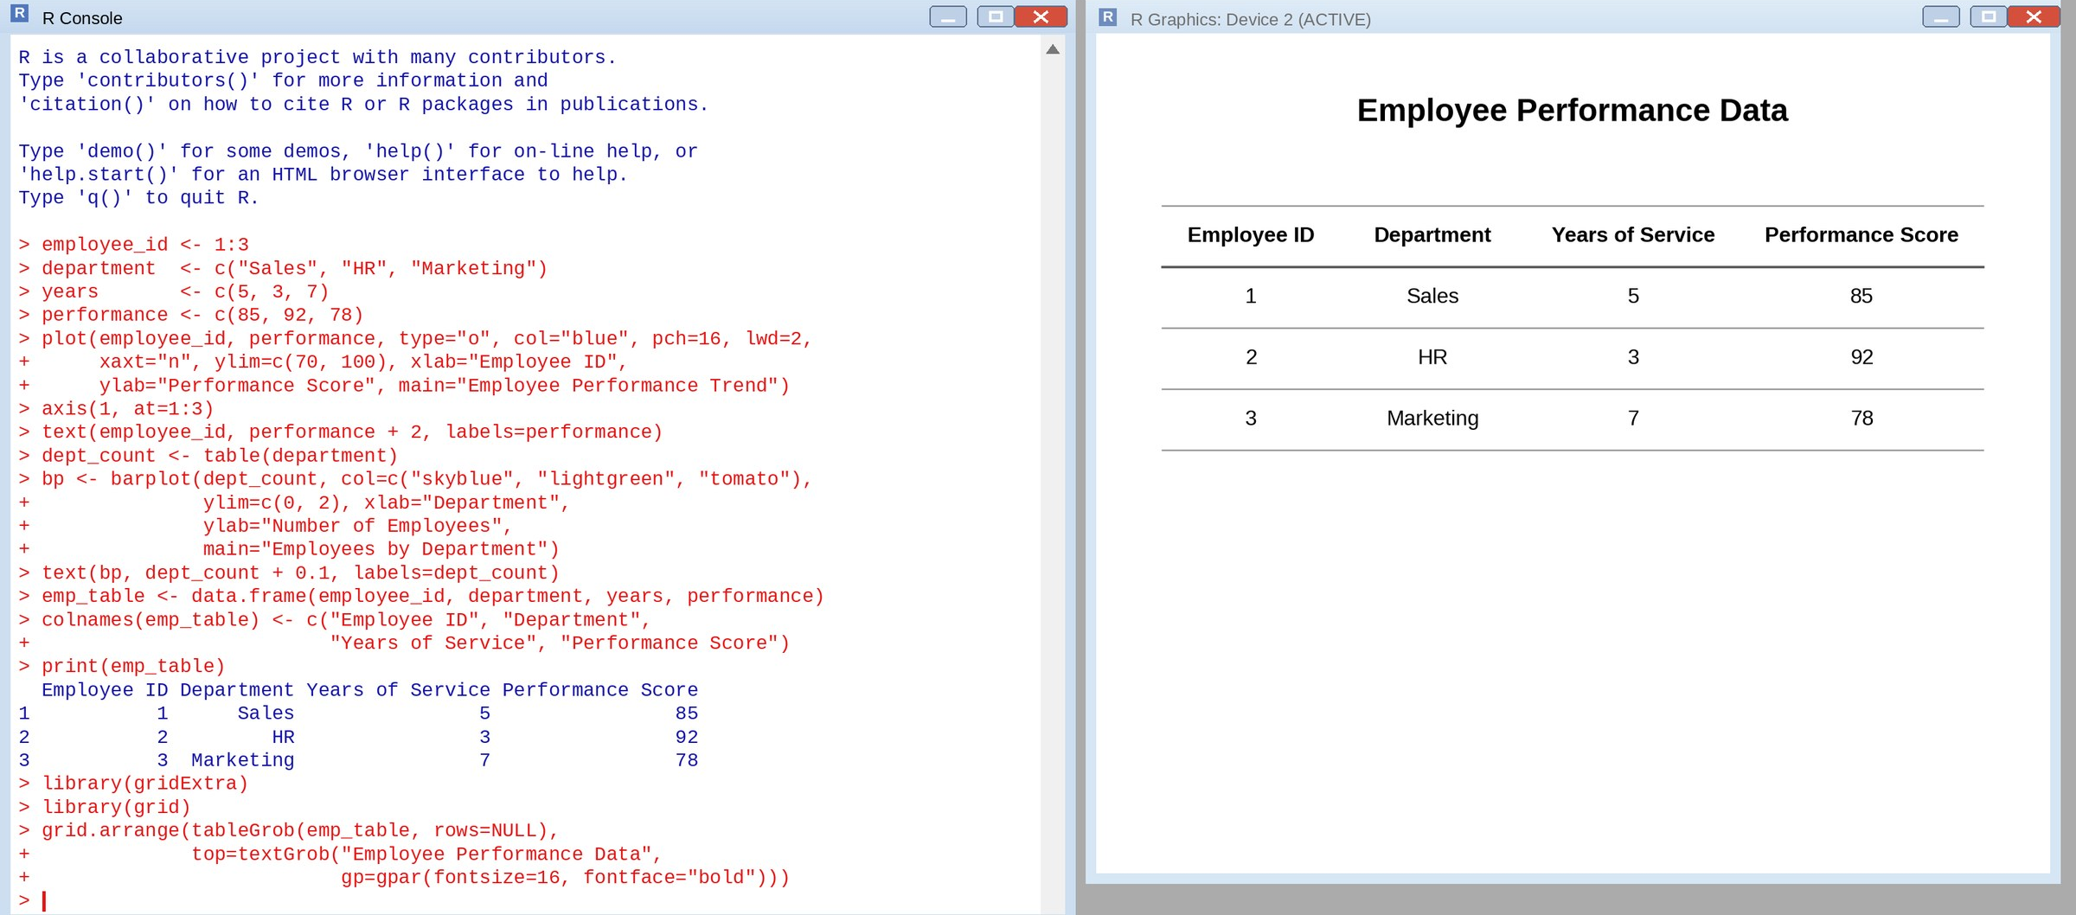

TABLEAU DASHBOARD - LINE CHART, BAR CHART AND TABLE
